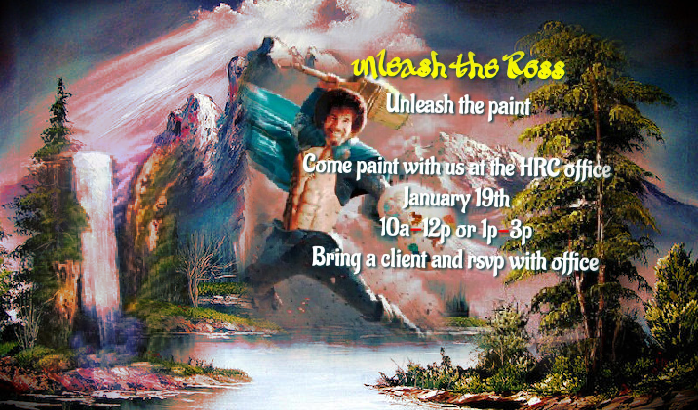
***Each month we will now be hosting a Heartland Community Event!!! The first will be this month and we will be having fun painting at the office with music!!! Please RSVP for this event so we can make sure we have enough paint supplies!! Any ideas for monthly activities will be appreciated!!!

